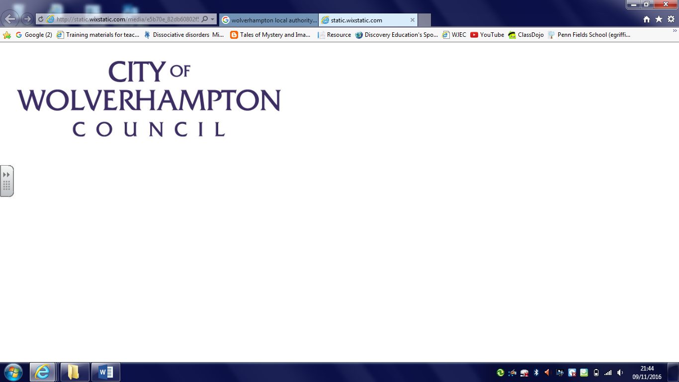


Wolverhampton Inclusion Team
Feedback following Individual Intervention

School/Professional Colleagues on Inclusion Officer support.
To be sent into schools as a Microsoft Form survey, when the Inclusion Officer sends the End of Intervention Report.
 | Yes | No | N/A
The referral was considered and initial communication was within 5 working days.
Communication from the Inclusion Officer was professional and informed school of all visits.
Feedback sheets after each session were shared with school within 24 hours.
The school feels the work carried out with the pupil has had a positive impact
The End of Intervention report was detailed. It suggests and signposts to next steps and support.
I will refer into the inclusion team again and recommend to other schools/colleagues.
Any additional information

